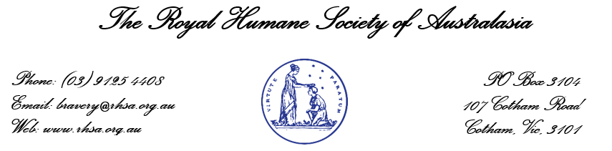
AWARD NOMINATION FORM

The Royal Humane Society of Australasia seeks to honour and recognise people who through their selfless acts of courage and bravery, have risked their own life in an attempt to save the lives of others.

Information Regarding Nomination

Thank you for your nomination. This form is designed to be filled out and sent electronically, but can be printed, completed by hand and then scanned or posted. The Society will investigate the incident and will advise you of the outcome. There must be more than one person nominating or supporting a nomination for it to proceed.

Please contact us at any stage at bravery@rhsa.org.au should you have any further information to support the nomination, or if you have any queries. Please fill in as much detail as possible as known.

Your Information
Title/rank
Name
Contact number
Email
Address
Name of Person Being Nominated
Title/rank
Name
Contact number
Person(s) Rescued or Attempted to be Rescued
Title/rank
Name
Contact number
Email
Address
Additional Nominators / Witnesses / Endorsers
(a minimum of one additional nominator, witness or endorser is required to advance the nomination)
Name |  | Contact Number
1)
2)

Incident Details (Please detail as much as possible & provide estimations if unsure)
Date of incident
Time of incident
Place of incident
Summary of the incident | Describe all details: involved parties, roles, cause, risk factors, outcome, etc.
Environmental conditions where the incident occurred | Describe all details: involved parties, roles, cause, risk factors, outcome, etc.
Supporting Information
Emergency response agencies involved | If known, please indicate any known emergency response agencies present.
Photographs, videos, media reports | Please attach copies of relevant photos, videos or media reports when submitting this form.
Other information | If applicable, please advise any additional information to support this nomination.
Signature of Nominator
Full name
Signature
(or date the email is sent to the Society)
Office Use Only
Case number: |  | Date:
RHSA Assigned: |  | RHSA Endorsed:
RHSA Specialists Assigned:
Investigation award outcomes:
Completion date:
Case notes:

